**ULTRA VOLTAGE GAIN BOOST CONVERTER FED BLDC MOTOR FOR FCEV APPLICATIONS**

**Abstract**

Fuel cell electric cars (FCEV) are becoming more popular in the automobile industry as a result of stringent laws on carbon dioxide emissions and fuel efficiency. Using an ultra-high voltage-gain dc-dc boost converter, a 1.26-kW proton exchange membrane fuel cell (PEMFC) is employed in this article to power an electric vehicle. DC-DC converters with high voltage gains and switching frequencies are necessary for FCEV propulsion. An ultra-voltage-gain boost converter is also created to achieve high voltage gain for the FCEV system. The fundamental working principle of this converter is to use switching inductors to achieve significant voltage gain while operating in continuous conduction mode and under steady-state analysis. This converter is composed of three switches, two capacitors, three inductors, and two diodes. Even at low duty ratios, the suggested converter allows for higher voltage gain. The suggested converter requires little voltage from the switches while having a large voltage gain. These characteristics make the suggested converter appropriate for use with electric vehicle applications. The low, unregulated DC output voltage from a PEMFC stack The PEMFC output voltage is managed with the aid of an ultra-gain boost converter. The boost converter is widely used as a front-end power conditioner for fuel cells. An inverter is used to transmit the output voltage of the recommended converter to the vehicle's electric motor for propulsion. An adequate motor considerably reduces the price and size of the fuel cell. Because of their simple control, high level of dependability, and longevity, permanent magnet BLDC motors are currently mostly used in FCEV applications. MATLAB software is used to conceptually test and model the suggested arrangement.

**Introduction**

Fuel cell electric vehicles (FCEV) are receiving more attention from the automobile industry as a result of environmental pollution and limited fossil fuel supplies. The huge increase in FCEVs has been made possible by the quick developments in fuel cell and power electronics technologies [1],[2]. Clean power generation, outstanding dependability, high efficiency, and little noise are all benefits of fuel cells [3]. A fuel cell can be classified as a membrane-based proton exchange fuel cell (PEMFC), an alkaline fuel cell (AFC), a phosphoric acid fuel cell (PAFC), a solid oxide fuel cell (SOFC), or a molten carbonate fuel cell (MCFC), depending on the kind of electrolyte used. PEMFCs are the market leader in the automobile sector due to their quick starting and low operating temperature [4].

Low DC voltage is produced as a result of the fuel cell stack. A step-up converter or more fuel cells must be added to the stack in order to produce larger DC voltages. In this specific design, instead of additional fuel cells, a straightforward boost converter is cascaded with a switching inductor circuit. A stack of PEMFCs is used to provide an unregulated low DC output voltage. To increase and regulate the PEMFC output voltage, a step-up or boost DC-DC converter is needed. A common front-end power conditioner for the fuel cell is the boost converter. For low power applications, the typical boost converter is utilized as a power electronic interface; but, owing to its weak current handling capability and problematic thermal management, it may not be appropriate for high power applications [5]. This article recommends a converter with an ultra-high voltage gain for use in fuel cell applications in order to minimize switching stress and maximize voltage gain.

In a quadratic boost converter, two boost converters collaborate. It is suggested in [6] and [7] to obtain high voltage gain. The system's overall efficiency, however, may suffer if two boost converters are used. In [8] and [9], a cascaded 2-phase inter-Leaved DC-DC boost converter is described. This architecture, however, is inefficient and unreliable. Despite the boost converter with a voltage multiplier cell being recommended in [10] and [11] to achieve high voltage gain, the voltage gain of a single multiplier cell is insufficient to power the FCEV's powertrain. According to [12] and [13], isolated converters with connected inductors or high frequency transformers will be able to achieve a significant voltage gain. Changing the transformer turns ratio results in a high voltage gain [14]. These DC-DC converters with isolation cost more than DC-DC converters without isolation. According to [15], the best way to achieve low switching stress and high voltage gain for fuel cell applications is to use a three-phase non-isolated interleaved boost converter (IBC). Fuel cell dependability is increased through interleaving, which also offers high power capability. Its design is incredibly complex, though.

The recommended converter's output voltage is routed through an inverter to the vehicle's electric motor for propulsion. The electric motor is essential for FCEVs. The price and size of the fuel cell are drastically reduced by a suitable motor. In the past, DC motors were frequently used by automakers in electric vehicle applications. DC motors, on the other hand, are less efficient and expensive to maintain because of the brushes and other moving parts [16]. Permanent magnet BLDC motors are currently the most popular option for FCEV applications due to their simple control, excellent dependability, and robustness [17]. 

*Fig 1: Proposed converter topology block diagram*

It consists of a BLDC motor, a voltage source inverter (VSI), an Ultra voltage gain boost converter, and a PEMFC. An interface between the PEMFC and VSI is controlled by the ultra-voltage gain boost converter. The BLDC motor is powered by an ultra-voltage gain boost converter through the use of VSI. The VSI switches are managed by a BLDC motor's electronic commutation. For propulsion, a motor shaft is attached to the wheels of the vehicle. We use one Hall Sensor per winding in three phase windings to deliver three overlapping signals with a 60° or 120° wide position range.

The essay is organized as follows. Fuel cell modeling is covered in Section II, the proposed converter is covered in Section III, modeling and control methodologies for BLDC motors are covered in Section IV, simulations and results are covered in Section V, and the conclusions are summarized in Section VI.

**Fuel Cell :**

A fuel cell is an electrochemical device that uses hydrogen fuel to generate electricity. With the help of a chemical reaction, the fuel cell converts the inputs of air and fuel into power and water. Numerous advantages exist for fuel cells. These work more efficiently—by more than 60%. They don't self-discharge and don't require charging. As long as fuel and oxygen are available, which they require to run continuously, they can generate power continuously. The parts of a single fuel cell are shown in Figure 3: an electrolyte, two electrodes (the anode and the cathode). The electrolyte separates the positive and negative charged ions of the hydrogen fuel. When the cell is fed with hydrogen and oxygen and has an electrolyte present, electricity is generated at the cell's output.

Reaction at anode and cathode is given by,

2H2 = 4H+

O₂+4H+4 = 2H₂O

Overall electrochemical reaction is given by,

H₂ + O₂ = H₂O+ Electrical Energy +Heat

The cell voltage of PEMFC is given as

(1)

Where is the open-circuit (or reversible) thermodynamic voltage and is given as

(2)

Where T is absolute temperature (K), Po2 and Ph2 are oxygen and hydrogen partial pressures (ATM) respectively. Activation voltage Vact is the combination of both anode and cathode activation overvoltage and is expressed as

(3)

Where (i = 1,2,3,4) is empirical coefficient for each cell and C is the dissolved oxygen concentration at the liquid/gas interface and is calculated by using the following expression

(4)

Ohmic overvoltage Vohm is expressed as

(5)

Where RM is the electron flow equivalent resistance and is the proton resistance. RC is considered as constant.

(6)

Where L is membrane thickness (cm), A denotes active area of membrane (cm2) and is the membrane specific resistivity (ohm-cm) and is given as

(7)

Where G is water content of the membrane and J is current density and is expressed as

(8)

Finally, the concentration overvoltage can be calculated from the following expression

(9)

Where Jmax is the maximum current density, R is the universal gas constant, and F is the Faraday constant. The fuel cell's output is connected to a DC-DC converter, which keeps the voltage across the DC link constant. Table 1 contains the 1.26kW PEMFC's design specifications.

*Table 1 1.26kW PEMFC parameter specifications*

|  |  |
| --- | --- |
| Parameter Description | Rating |
| Maximum power Pmax | 1.26kw |
| Maximum Current Imax | 52A |
| Maximum Voltage | 24.23V |
| Temperature T |  |
| Number of Cells | 42 |
| Nominal airflow Rate | 2400 lpm |
| Stack power | Nominal = 1259.96W  Maximal = 2000W |
| Fuel cell Resistance | 0.061871 ohms |
| Fuel flow rate | Nominal =12.2 lpm  Maximum = 23.46 lpm |
| Air flow rate | Nominal =2400 lpm  Maximum = 4615 lpm |
| Fuel supply pressure | 1.5 bar |
| Air supply pressure | 1 bar |

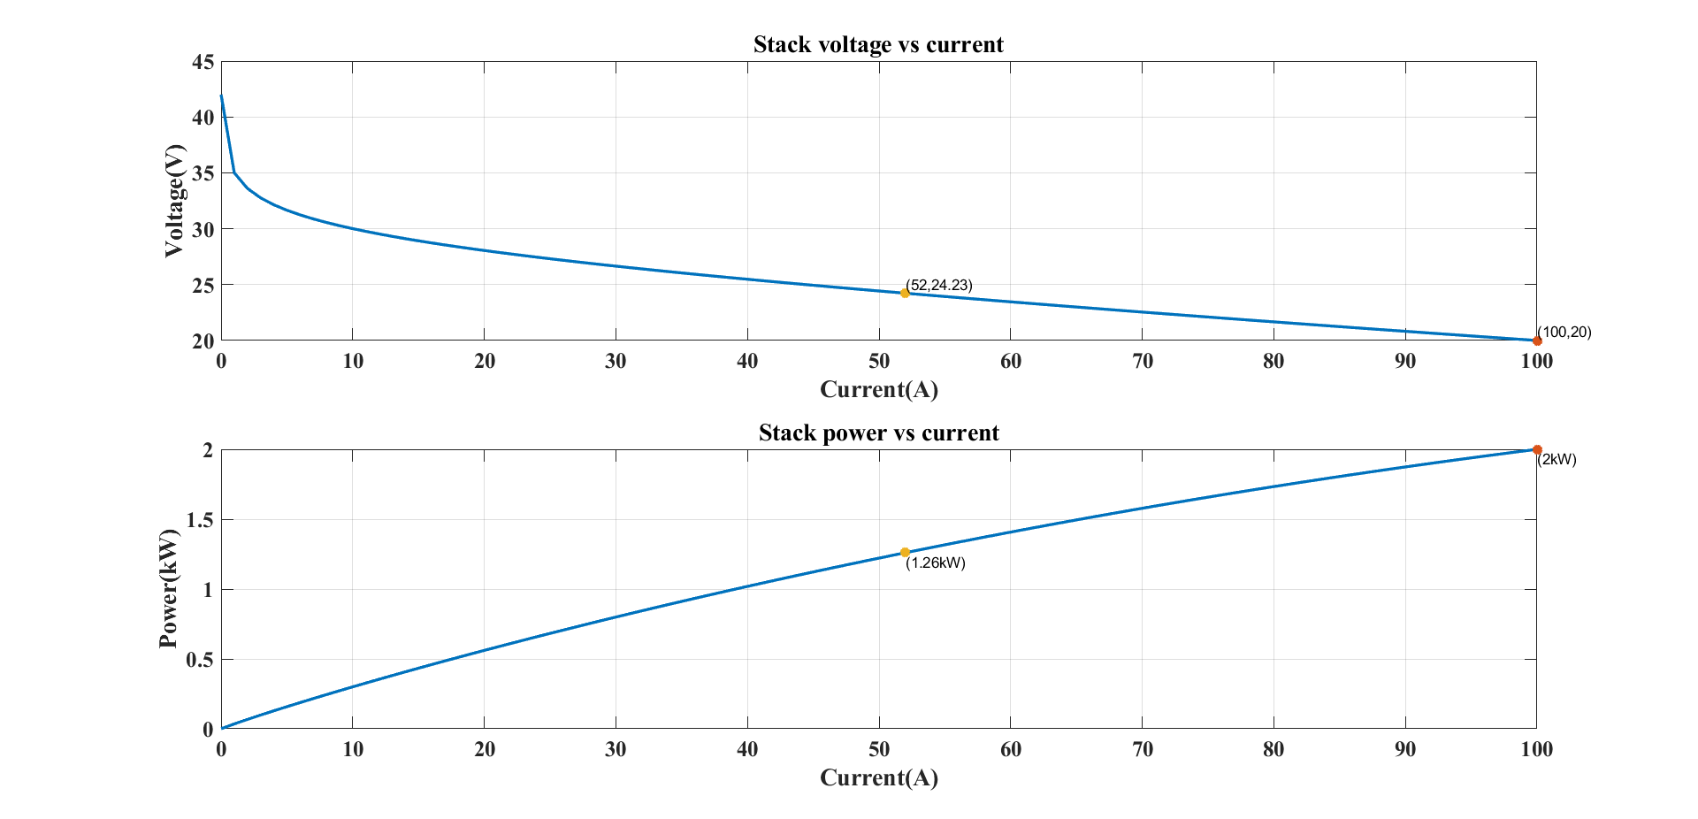

*Fig 4 V-I Characteristics of PEMFC*

**Proposed Ultra Gain Boost Converter**

The configuration of the suggested converter is shown in Figure 5. It has two diodes, three inductors, two capacitors, and three switches. The three switches are activated and deactivated simultaneously.Continuous conduction mode (CCM) operation is how the converter is intended to work. Figure 5 displays a graph of the ideal key waveforms for the circuit devices. 

*Fig 5 The proposed configuration circuit*

*Table 2 The voltage stresses of the switching devices.*



*Fig 6 The ideal key waveforms of the converter*

|  |  |
| --- | --- |
| **Switching Device** | **Peak Voltage Stress** |
|  | *Vo* ∗ (1 − *D*)/(1 + *D*) |
|  | *Vo*/(1 + *D*) |
|  | *Vo*/(1 + *D*) |
| *Dx* | *Vo* ∗ (1 − *D*)/(1 + *D*) |
| *Dy* | 2 ∗ *Vo*/(1 + *D* |

The voltage and current stresses of each component are displayed in Tables 2 and 3. The output voltage is not the highest voltage stress placed on any of the components. This is a very obvious benefit of this topology. It gives us the option to select devices with low ratings, which improves the system's overall effectiveness & efficiency. However, a large conversion ratio necessitates the use of numerous diodes and capacitors. The turns ratio is used in isolated topologies, including coupled inductors and flyback converters, to control the converter voltage gain in addition to the duty cycle. If the necessary step-up ratio is performed at a moderate duty cycle, the overall efficiency is increased.

*Table 3 The current stresses of the switching devices*.

|  |  |
| --- | --- |
| **Switching Device** | **RMS Current Stress** |
|  | *Iin* ∗ |
|  | (1 − *D*) ∗ ∗ *Iin*/2 |
|  | (1 − *D*) ∗ ∗ *Iin*/2 |
| **Freewheeling Diodes** | **Average Current Stress** |
| DX | *Iin* ∗ (1 − *D*) |
| Dy | (1 − *D*)2 ∗ *Iin*/2 |

Equations from tables 2 and 3 represents the relationship between the voltage across capacitor *C*1 and input/output voltages.

The output of the basic boost converter is supplied into the switched inductor circuit, which enhances the voltage level and supplies a suitable voltage at the output side, in the ultra-gain boost converter. This BLDC motor powers the wheels of a vehicle through the vehicle transmission system, and switches of the VSI are controlled by employing electronic commutation of the BLDC motor. The output voltage of the proposed converter is delivered to the BLDC motor through an inverter for propulsion of the vehicle.

**BLDC Motor**

The Lorentz force law, which states that "whenever a current-carrying conductor is placed in a magnetic field, it experiences a force," serves as the foundation for BLDC motor operation. A force that is equal to and opposing to the reaction force experienced by the magnet will be experienced. A BLDC motor's controller regulates its rotational speed, torque, starting, stopping, and reversing. According to a similar theory, both the brushed motor and the BLDC motor produce rotational motion through the attraction and repulsion of magnetic poles in both permanent and electromagnets. These BLDC motors are, however, controlled very differently from conventional motors. BLDCs require a sophisticated controller to convert a single DC power to three-phase voltage, unlike brushed motors, which can be controlled by adjusting the DC voltage. The BLDC motor control system uses hall effect sensors to determine the rotor's position. The sensors measure the rotor position and transmit that data. The controller instructs the switches to switch the current and energize the required stator winding at the proper time after receiving the information from the sensors.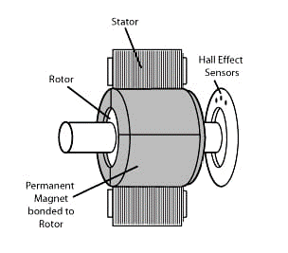 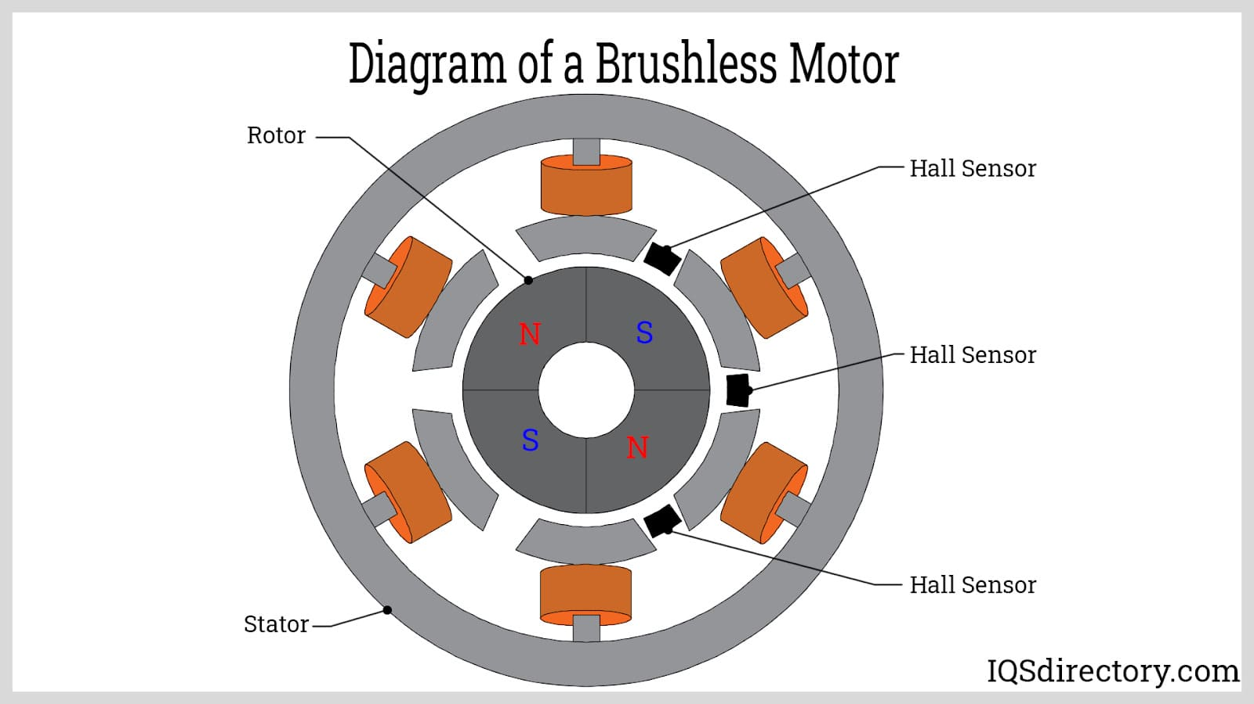

*Fig 9 BLDC Motor construction*

**BLDC Motor Modelling**

The Y-connected, 3-phase motor has a 4-pole permanent magnetic rotor and is powered by a PWM inverter. The equivalent circuit diagram for the stator winding is shown in Fig. 10. The rotor position, which governs the switching order of the IGBT transistors, is sensed by three Hall sensors on the rotor. The switching scheme used by the inverter logic is well known.

Three equations make up the model equations for a BLDC motor: the motion equation, the torque equation, and the voltage equation. An induction motor or a permanent magnet synchronous motor has three windings on the stator, while a general purpose BLDC motor has two.



*Fig 10 Circuit Diagram of Stator Winding*

From the fig 10 stator winding, the equations of the 3-phase brushless dc machine are as below,

(10)

(11)

(12)

Where Va, Vb, and Vc are the phase voltages, Ia, Ib, and Ic are the phase currents, R, L are the stator phase resistance, self-inductance and Ea, Eb and Ec are the back emf of phase A, B, and C, respectively. The back emf voltages are functions of the rotor mechanical speed and the rotor electrical angle θr, that is the coefficients Ka, Kb, and Kc are dependent on the rotor angle θr. The mechanical equations are

(13)

Where B is a coefficient, Tl is the load torque, and P is the no. of poles. The coefficient B is calculated from the moment of inertia J and the mechanical time constant Tm as below.

(14)

(15)

**VSI and BLDC motor**

The inverter is only used for dc-to-ac conversion, properly energizing the stator coils to enable smooth operation of the BLDC motor. The hall sensors, which are mounted on the motor, provide hall signals, which are then converted to EMFs for each phase, and the inverter is switched in accordance with those EMFs.

**BLDC motor Controller and commutation**

In a brush DC motor, commutation happens at the brushes where the reverse current flows, but in a BLDC motor, commutation happens with the aid of three-phase inverter switching sequences, which is why it is known as electronic commutation.

*Table 4 Truth Table for BLDC drive with Hall Sensor*

|  |  |  |  |  |  |  |  |  |  |  |  |
| --- | --- | --- | --- | --- | --- | --- | --- | --- | --- | --- | --- |
| **ha** | **hb** | **hc** | **Emf a** | **Emf b** | **Emf c** | **Q1** | **Q2** | **Q3** | **Q4** | **Q5** | **Q6** |
| 0 | 0 | 0 | 0 | 0 | 0 | 0 | 0 | 0 | 0 | 0 | 0 |
| 0 | 0 | 1 | 0 | -1 | +1 | 0 | 0 | 0 | 1 | 1 | 0 |
| 1 | 11 | 0 | -1 | +1 | 0 | 0 | 1 | 1 | 0 | 0 | 0 |
| 0 | 1 | 1 | -1 | 0 | +1 | 0 | 1 | 0 | 1 | 1 | 0 |
| 1 | 0 | 0 | +1 | 0 | -1 | 1 | 0 | 0 | 0 | 0 | 1 |
| 1 | 0 | 1 | +1 | -1 | 0 | 1 | 0 | 0 | 0 | 0 | 0 |
| 1 | 1 | 0 | 0 | +1 | -1 | 0 | 0 | 1 | 0 | 0 | 1 |
| 1 | 1 | 1 | 0 | 0 | 0 | 0 | 0 | 0 | 0 | 0 | 0 |

In order to operate the BLDC motor, the inverter must operate in the correct order. Hall sensors are mounted on the motor at intervals of 60 degrees, and the generated Hall signal is processed with the aid of the switching table shown below as Table 4.

**Speed control system**

A controller circuit must be used to run the BLDC motor and control its speed. However, they are typically separated into closed loop and open loop control systems. Systems with high levels of accuracy employ closed loop techniques. In Fig. 11, a block diagram of a BLDC motor speed controller, two closed loop systems are used. In this case, the internal loop is used for tuning and power supply polarity sensing while the external loop is used to control the speed. The motor speed controller can be used to change the DC bus voltage. The value of the DC supply, which is required to control the system, depends on the motor's capacity and rotational speed (rpm). A PID controller is used because this system also requires a controller, and it eventually regulates the inverter output voltage. A sensor is necessary for a closed loop controller that controls a motor's speed. The main responsibility of the sensor is to translate the precise location and state of the motor shaft into an appropriate electrical signal for the controller circuit. An inverter circuit is required to convert the DC power supply voltage into an equivalent AC supply voltage because BLDC motors frequently require an AC-like voltage-waveform to function.



*Fig 11 Block Diagram of BLDC Motor Speed Control*

**The Back Electro Motive Force (BEMF)**

A full-bridge power converter using six electronic switches (power transistors) typically supplies a three-phase BLDC motor with three-phase voltage simultaneously. The transistors' rotor positions will be used to determine the switching order. Three hall sensor devices are typically used to keep an eye on the motor starter. The decoder block requires data from the hall sensors to produce the sign of the reference current signal vector to the back electromotive force (BEMF). To operate the motor in the opposite direction, either the current is changed in the opposite direction, or the switching order in the controller is changed. The simulation block diagram in MATLAB for producing the decoder's back EMF is shown in Fig. 12. Similar to Table 4, Fig. 13 shows the functional block diagram of the inverter switching for MATLAB simulation, and Table 4 shows the decoder sequences of the proposed 3-phase PID controller for the BLDC motor to rotate counterclockwise.

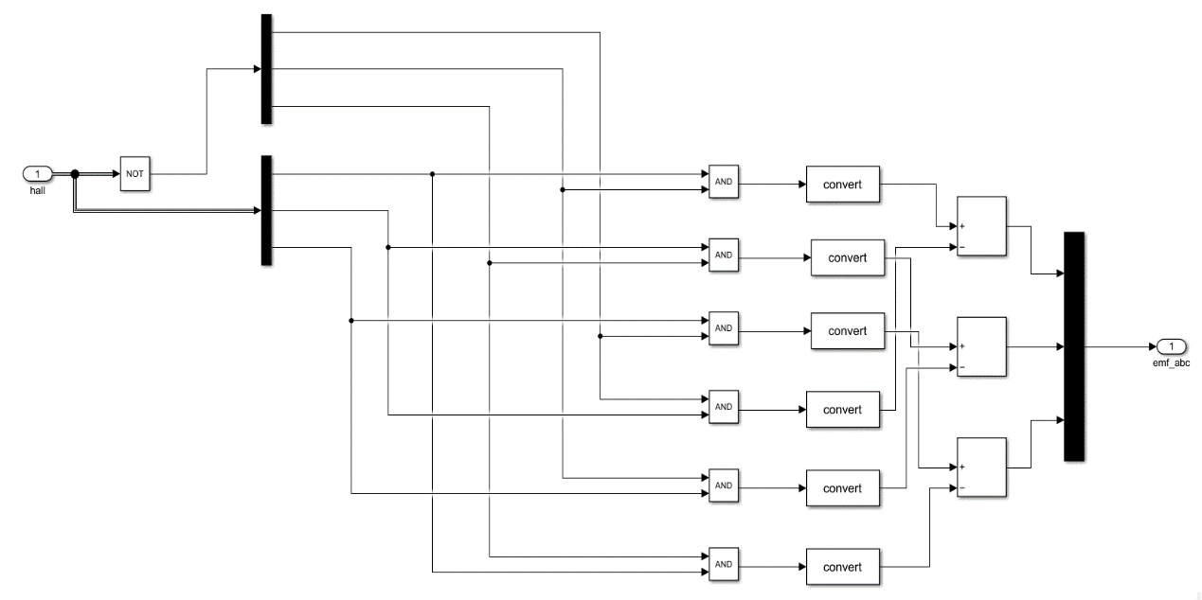

*Fig 12 Back EMF of Decoder for MATLAB Drive.*

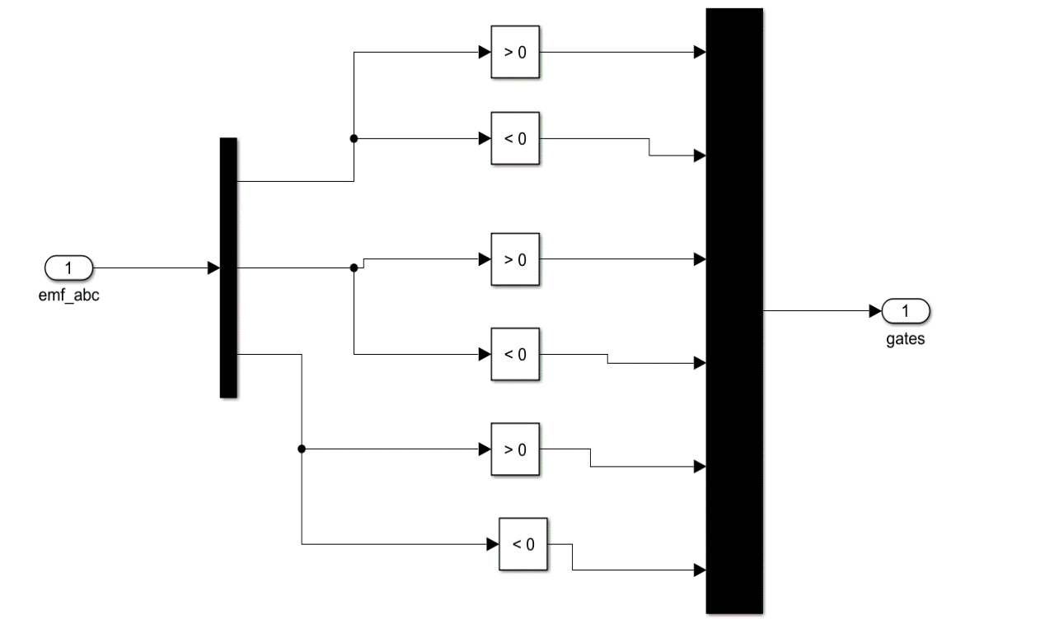

*Fig 13 Inverter Switching for MATLAB Drive*

*Table 5 Simulation component values*

|  |  |  |
| --- | --- | --- |
| Component | Description | Specification |
| Vin | Input Voltage | 20-35 V |
| V0 | Output Voltage | 100-350 V |
| LX | Inductor | 3µH |
| LY, LZ | Inductors | 3µH |
| CX | Input Capacitor | 260 µF |
| CY | Output Capacitor | 260 µF |
| DX | Power Diode | BYE72EW-200 |
| D0 | Output Diode | BYE72EW-200 |
| P0 | Rated Output Power | 2.5KW |

According to table 5, the input voltage range for this converter is 20V–35V. It is advisable to use higher switching frequencies (fs) for the projected converter because it is intended to have an output power of 2.5 KW. Three inductors and two capacitors are among the five energy components in the proposed converter. The simulation diagrams for the suggested converter and the entire suggested configuration are shown in Figures 14 and 15.

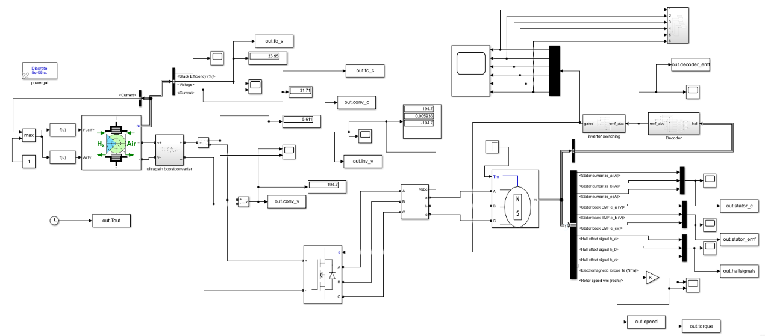

*Fig 15 Simulation diagram of the whole proposed configuration*

**Simulation results of proposed configuration**

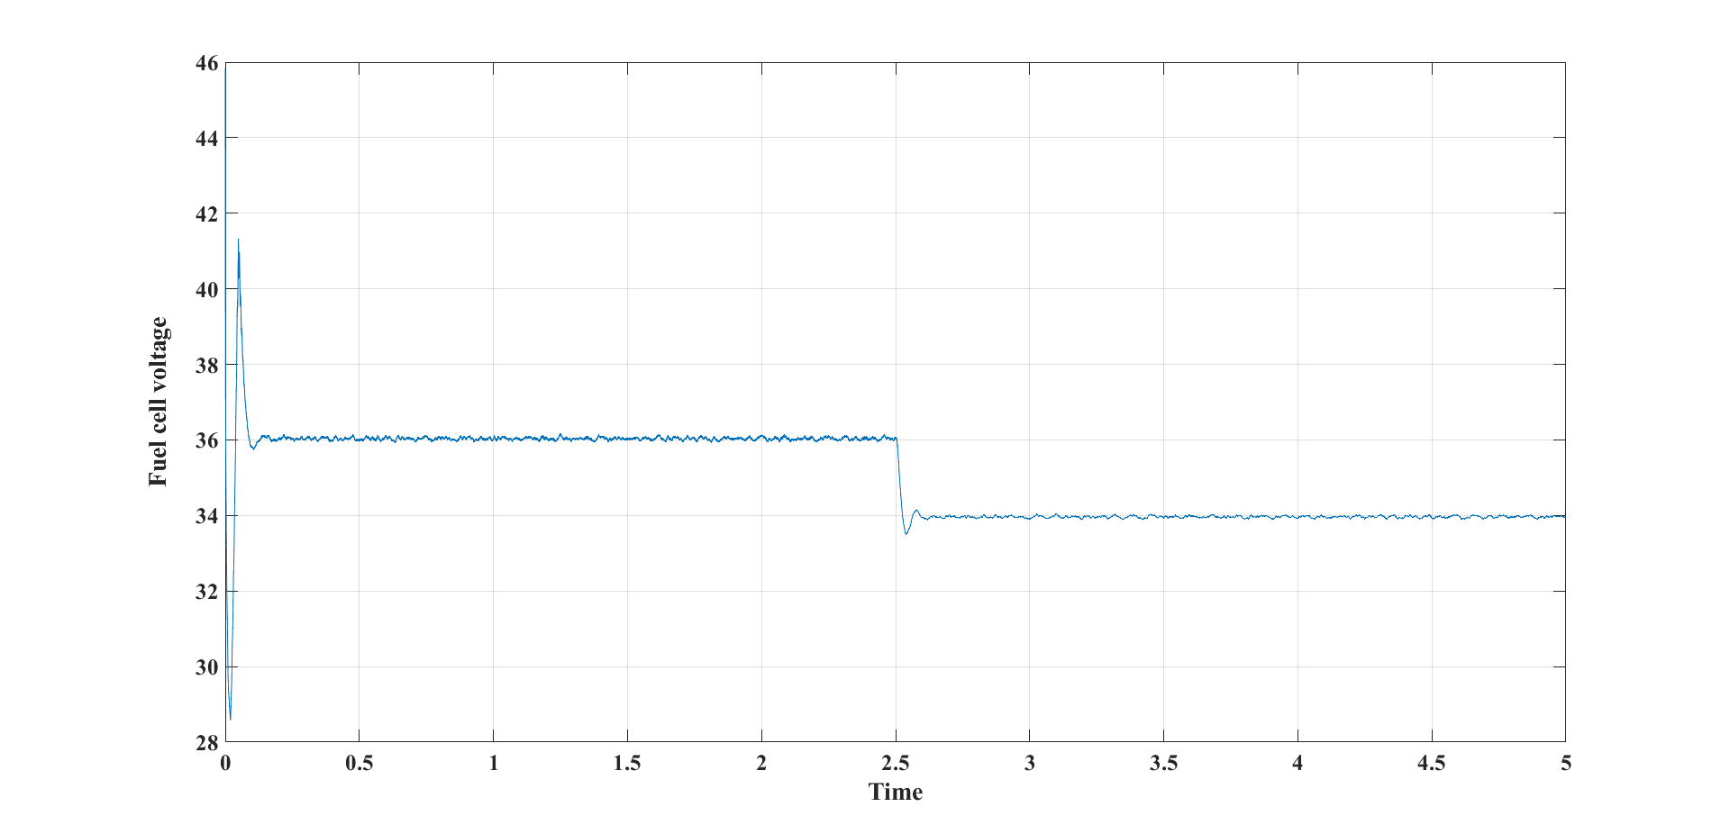

*Fig 16 Fuel cell voltage vs time*

The fuel cell voltage is displayed in Fig. 16. The fuel cell generated voltage and the time in seconds (sec) were represented by the X and Y axes in this diagram. After 0.1 seconds, the fuel cell voltage is 36V, and after 2.5 seconds, the load torque causes it to drop to 34V. The converter's input is powered by the fuel cell's output voltage.

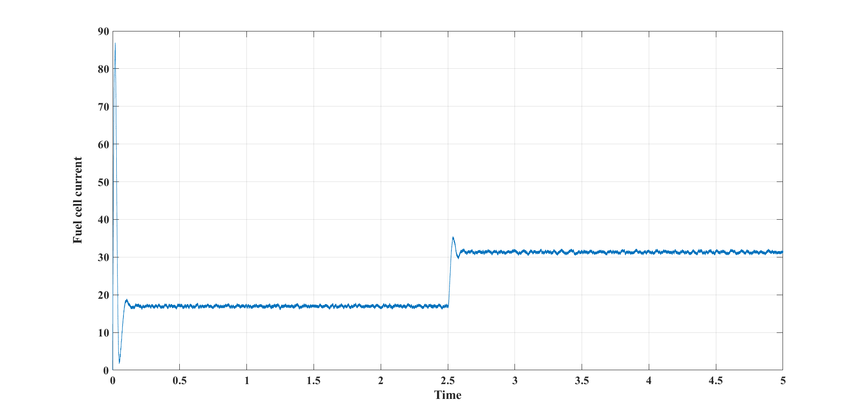

*Fig 17 Fuel cell current vs Time*

The generated fuel cell current, which is on the input side, is shown in Fig. 17. The time in seconds (sec) and the fuel cell current (amps) are shown on the x- and y-axes, respectively. After 0.1 seconds, the fuel cell current is roughly 18 amps, and after 2.5 seconds, an increase in the load causes it to rise to 31 amps.

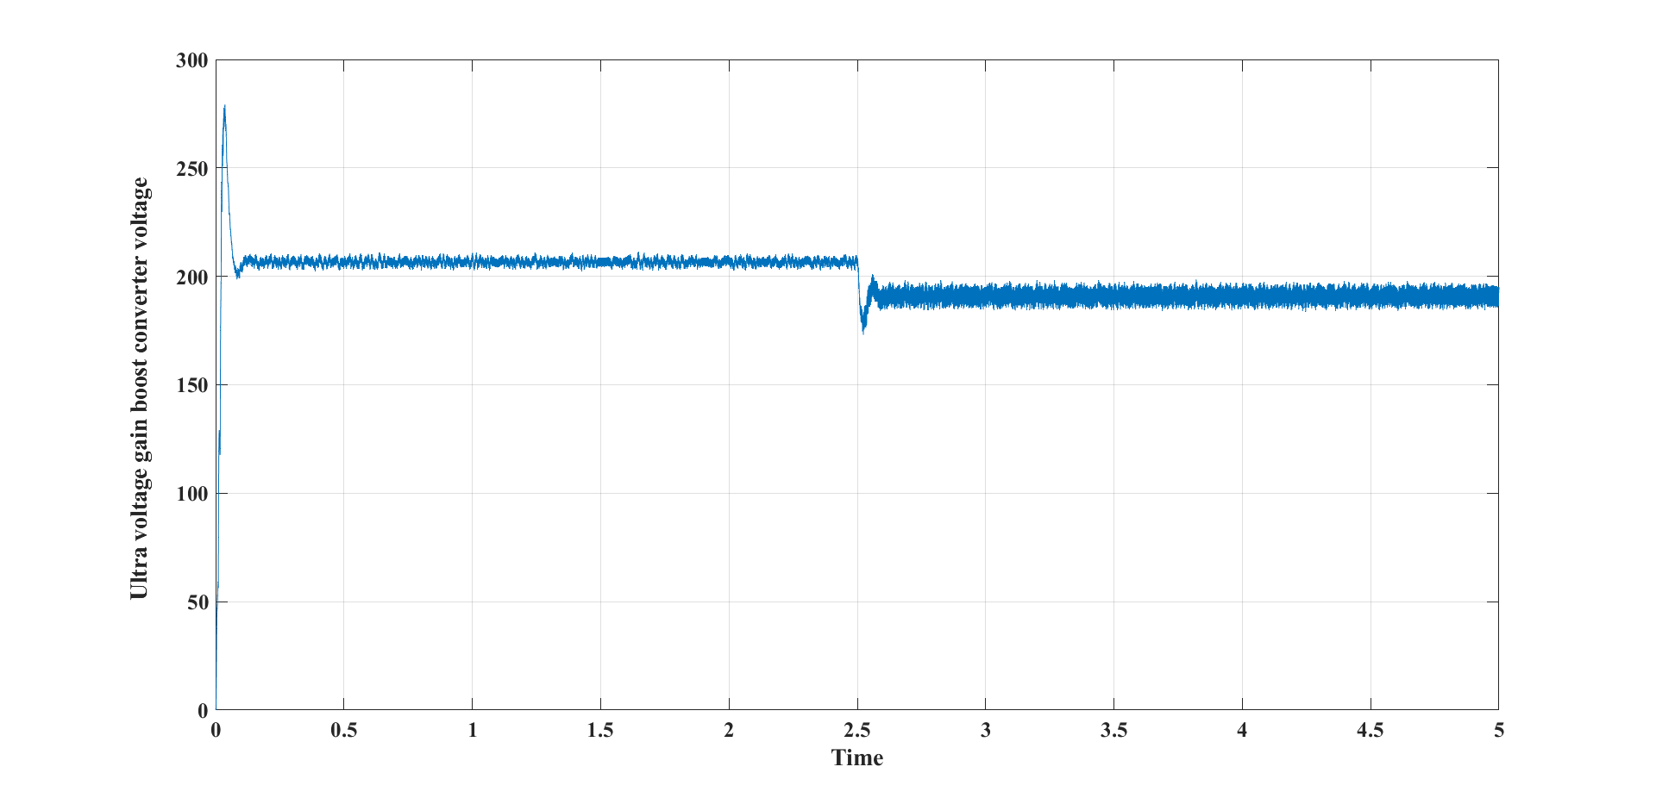

*Fig 18 Boost Converter voltage vs Time*

The voltage of an ultra-gain boost converter is shown in Fig 18. The time in seconds (sec) and the boost converter voltage (volts) are shown on the x- and y-axes, respectively. The output voltage of an ultra-gain boost converter is shown in the figure to be around 210V, which is roughly five times higher than the output voltage of a fuel cell.

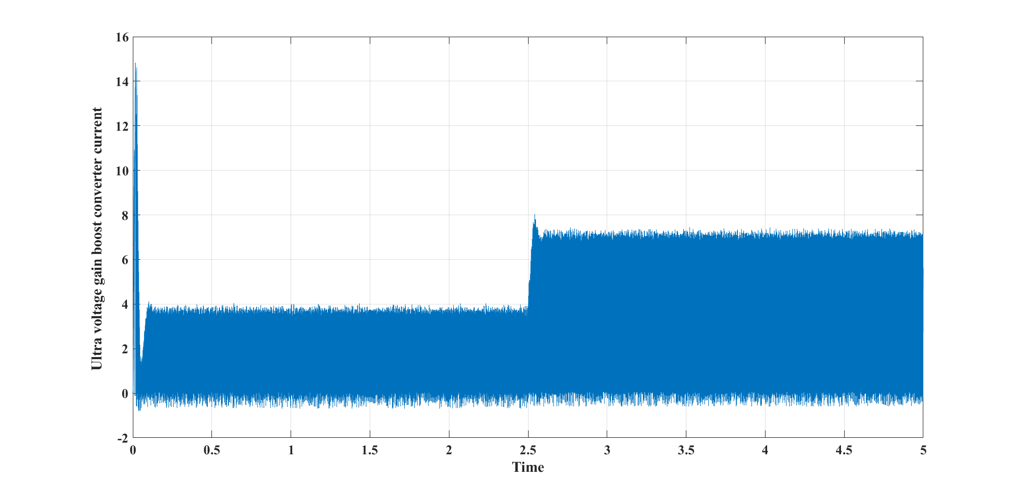

*Fig 19 Boost converter Current vs Time*

The ultra-gain boost converter current is depicted in Fig. 19. The time in seconds (sec) and the ultra gain boost converter current (amps) are shown on the x- and y-axes, respectively. The current increased roughly to 7.5 amps in 2.5 seconds as the step load increased at the load side.

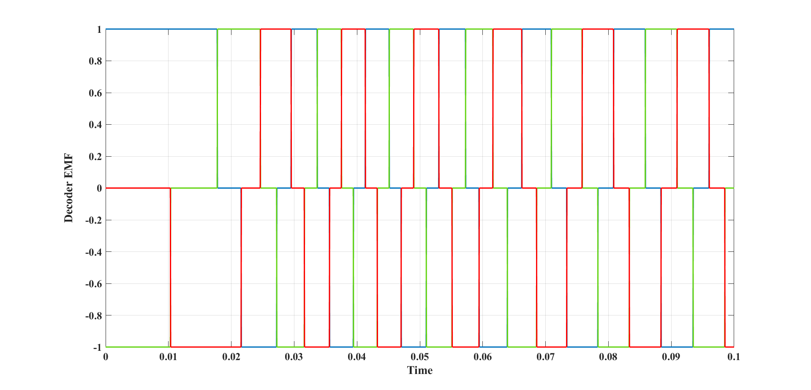

*Fig 20 Decoder- EMF pulses of respective A, B & C Hall signals*

The EMF pulses of the corresponding A, B, and C Hall signals are shown in Fig. 20. The A, B, and C Hall signals' respective EMF pulses and time in seconds (sec) are represented on the x- and y-axes, respectively. As shown in the above figure, the decoder converts the corresponding A, B, and C Hall signals into the corresponding EMF pulses. As seen in the example above, depending on the respective Hall signals, EMF pulses range between 0 and 1 and 0 and -1.

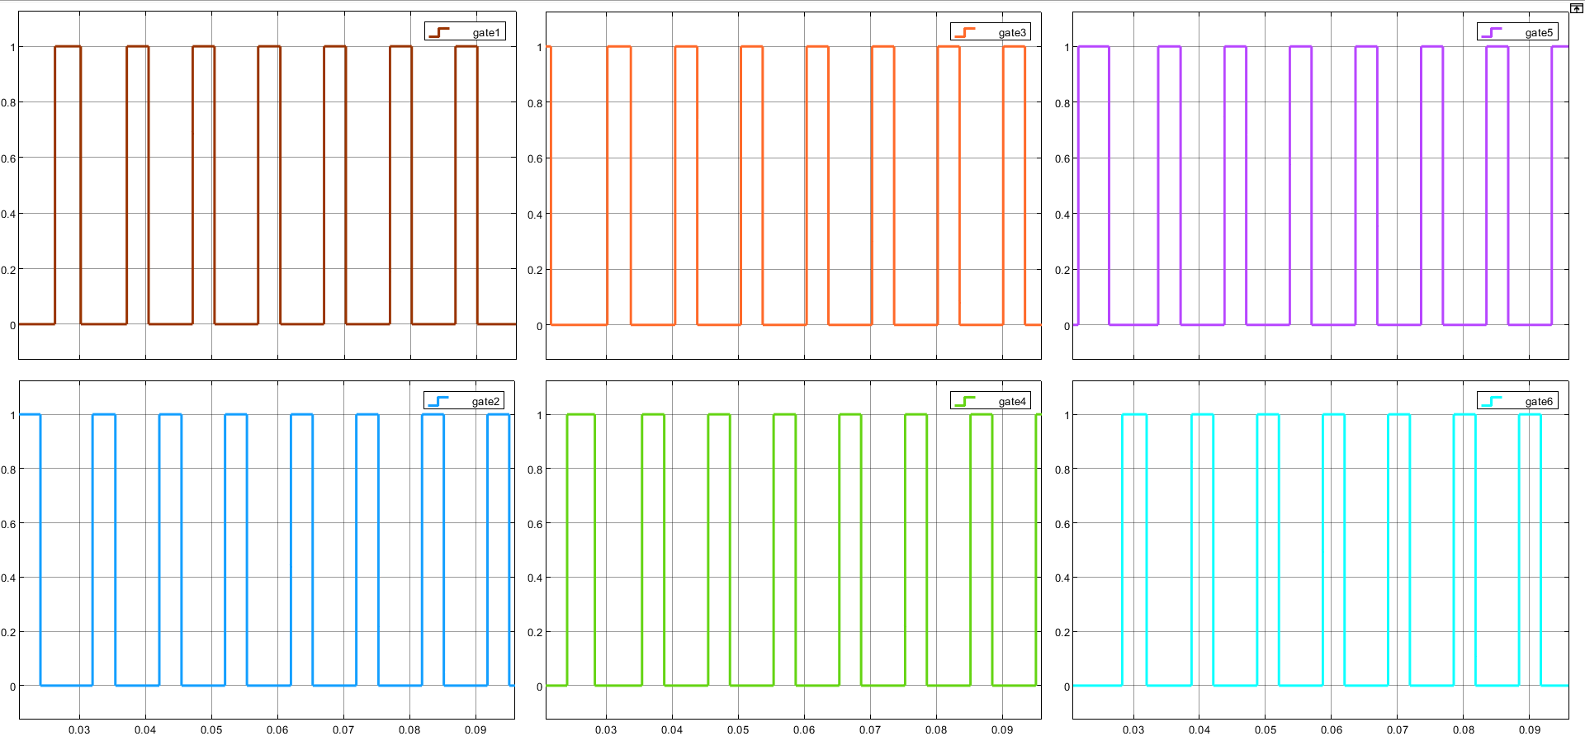

*Fig 21 Gate Pulses Provided by Inverter- Switching Block*

Gate pulses delivered by the inverter switching block are shown in Fig. 21. Gate pulses and time in seconds (sec) are represented by the x- and y-axes, respectively. The gate pulses range from 0 to 1. These are the six gate pulses that can be individually applied to each of the six inverter switches.

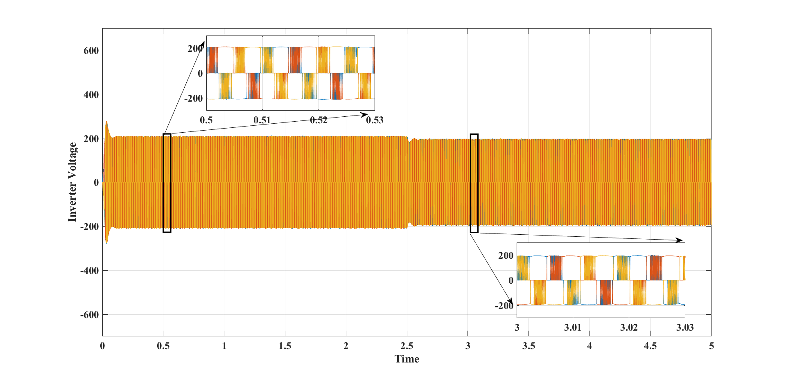

*Fig 22 Inverter Output Voltage*

The inverter output voltage is shown in Fig. 22. The time in seconds (sec) and output voltage of the inverter are represented by the x- and y-axes, respectively. The inverter's output voltage ranges from -200 to +200.

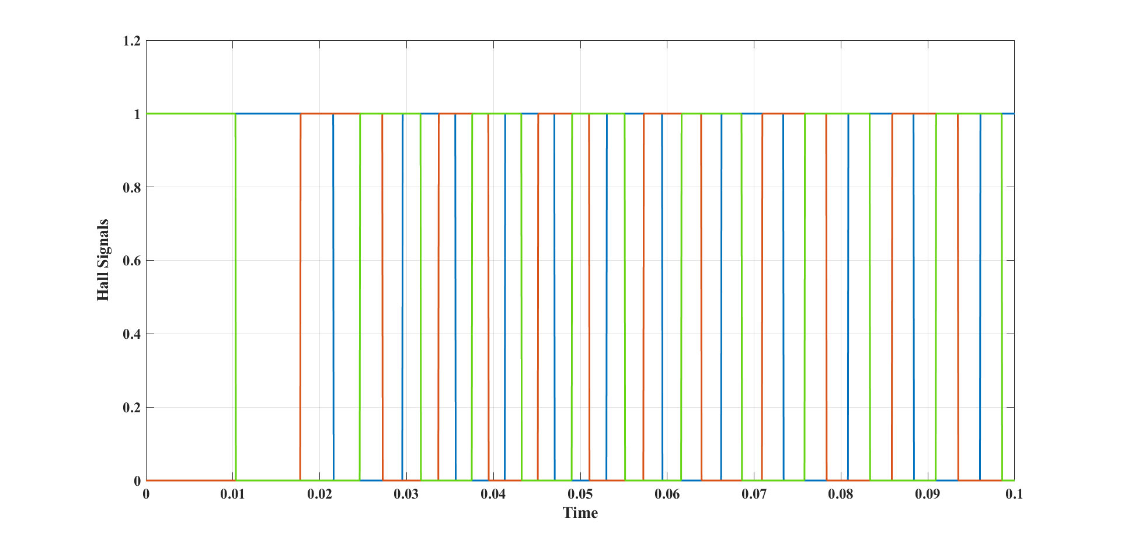

*Fig 23 Hall Signals vs Time*

Based on the position of the rotor of the BLDC motor, Fig. 23 depicts the hall signals produced by the Hall sensors, which are typically mounted on the rotor. The time is shown on the x-axis and the hall signals are shown on the y-axis. When the signals range from 0 to 1, the width of the signals varies at all times.

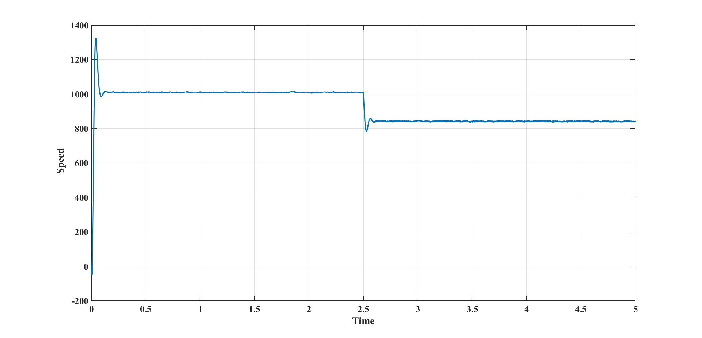

*Fig 24 Speed Vs time*

Fig. 24 displays the performance of the planned brushless DC motor. The X and Y axes in this diagram represented the speed of the BLDC motor (rpm) and the time in seconds (sec). The graph shows how the BLDC motor's speed changes over time. The speed is approximately 1000 rpm for the first 2.5 seconds. When the load torque suddenly increases at the 2.5-second mark, the speed drops to 800 rpm. When analyzing the performance of a BLDC motor, the speed characteristics are extremely important.

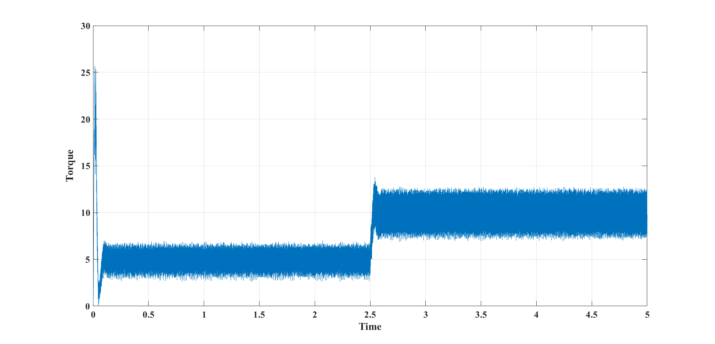

*Fig 25 Torque vs Time*

The output torque response capabilities of the BLDC motor are displayed in Fig. 25. The X and Y axes in this diagram represent the electromagnetic torque value of the BLDC motor in Newton-meters (Nm) and time in seconds (sec). At 2.5 seconds, the load torque suddenly increases from its initial value of 5 to a value of 10, along with the electromagnetic torque waveform. On the BLDC motor, it displays the applied torque value. When evaluating the performance of BLDC motors, torque characteristics are extremely important.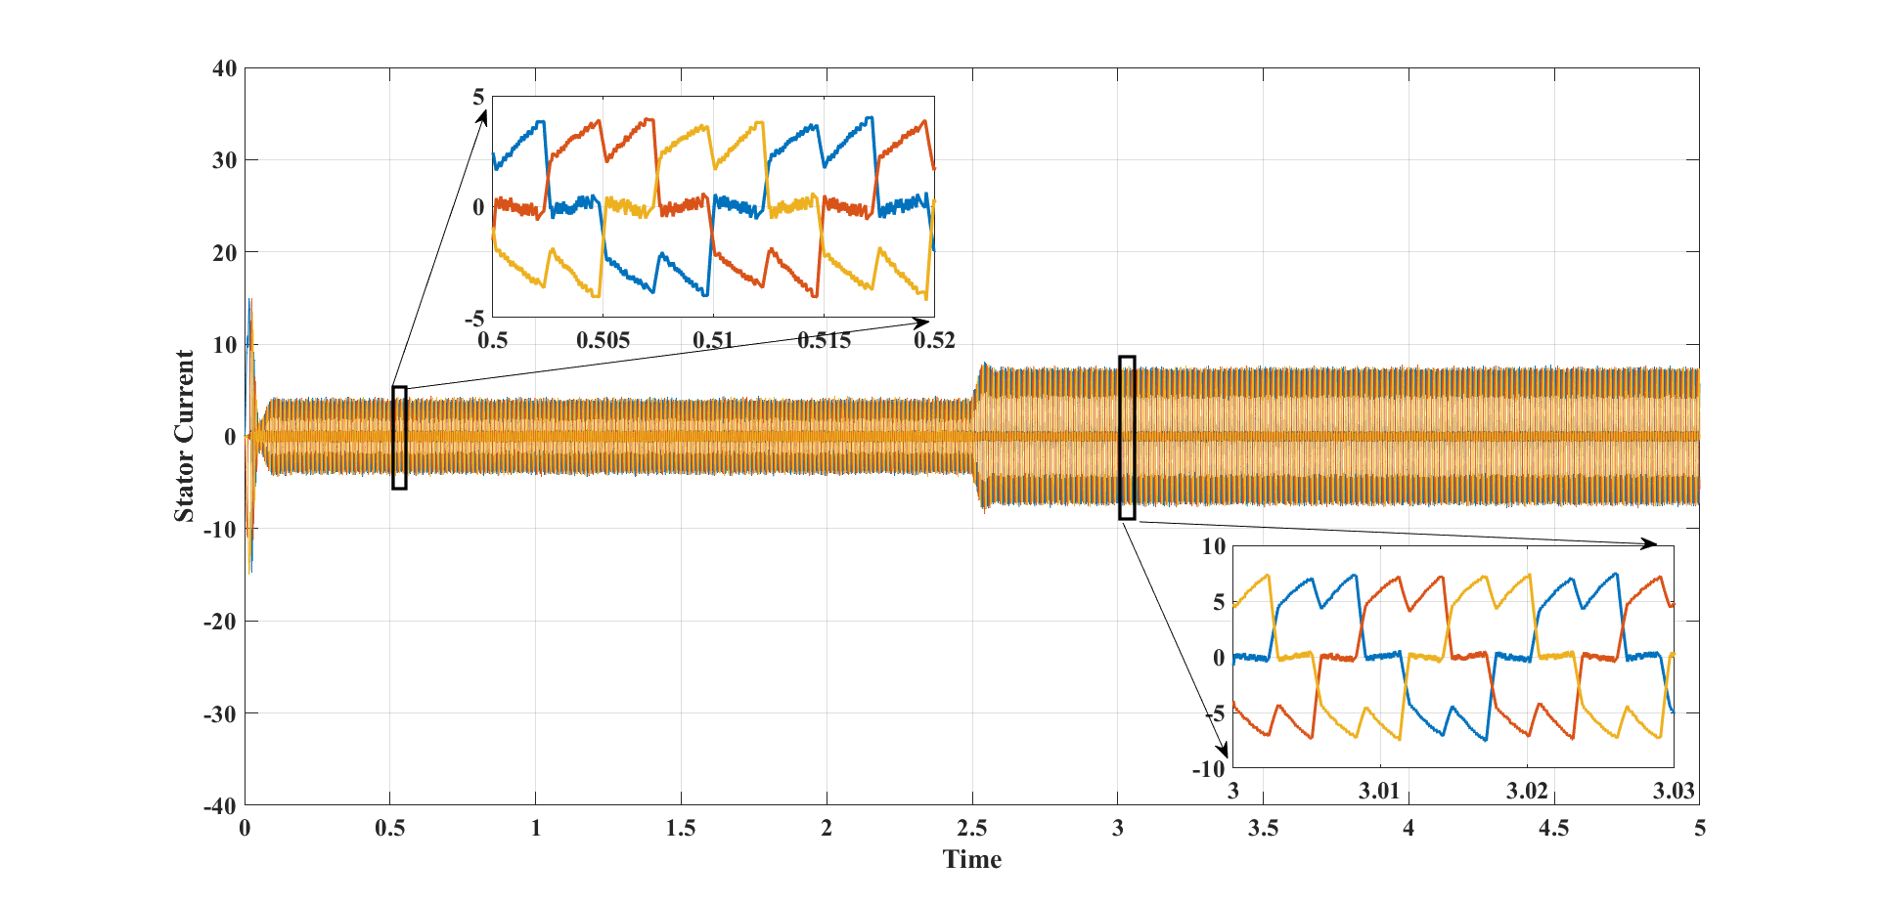

*Fig 26 Stator Current vs Time*

The stator current is shown in Figure 26. The time in seconds (sec) and stator currents (amps), respectively, are represented on the x- and y-axes. The stator currents range from -4 to +4 and from 2.5 seconds on, they range from -7 to +7. Stator currents increased at 2.5 seconds as load torque increased. Different hues represent the respective A, B, and C phases stator currents.

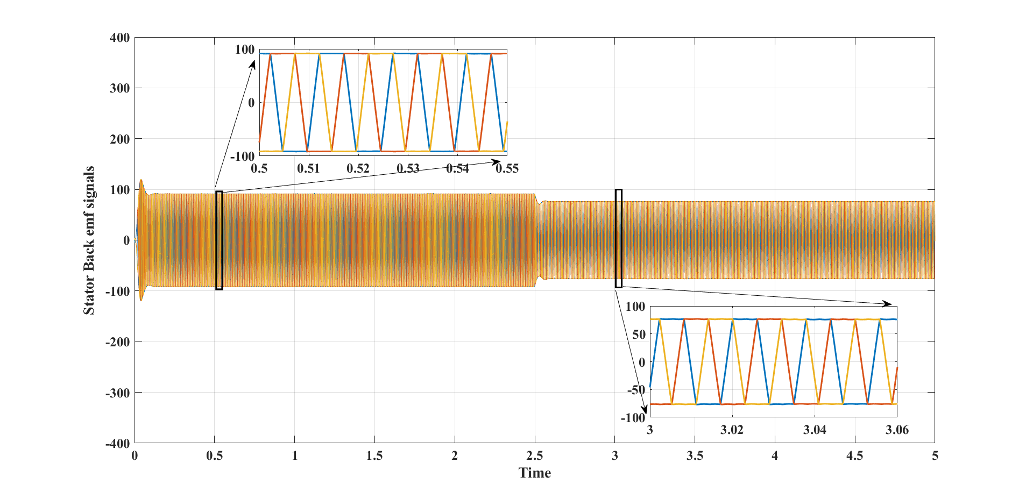

*Fig 27 Stator Back emf signals Vs Time*

The trapezoidal-shaped Back EMF signals for the A, B, and C phases are depicted in Fig. 27. The Back EMF voltage decreases at 2.5 seconds as the load torque increases abruptly at that same time. The X and Y axes in this diagram represented the BLDC motor's back emf value in Volts (V) and time in seconds (secs). The figure, respectively, shows the 3-phase back emf voltages of the BLDC motor. The figure makes it clear that the three-phase back emf voltages are fixed at 84V.

**Conclusion**

In this article, a BLDC motor fed by an ultra-high Voltage gain DC-DC boost converter is proposed for FCEV applications. The proposed converter has decreased the input current fluctuations of the fuel cell and the voltage stress on the power semiconductor switches. Three switches, two diodes, and three inductors made up the converter that was created. A simulation analysis of the converter revealed its high voltage gain, low voltage and current stress, and high efficiency. A three-phase BLDC motor controller has been designed and its performance analyzed with success. The obtained Simulation results were consistent with the configuration's theoretical analysis.

**References**

[1] H.-J. Chiu and L.-W. Lin, ‘‘A bidirectional DC-DC converter for fuel cell electric vehicle driving system,’’ IEEE Trans. Power Electron., vol. 21, no. 4, pp. 950–958, Jul. 2006.

[2] B. Geng, J. K. Mills, and D. Sun, ‘‘Combined power management/design optimization for a fuel cell/battery plug-in hybrid electric vehicle using multi-objective particle swarm optimization,’’ Int. J. Autom. Technol., vol. 15, no. 4, pp. 645–654, 2014.

[3] H. Hemi, J. Ghouili, and A. Cheriti, ‘‘A real time fuzzy logic power management strategy for a fuel cell vehicle,’’ Energy Convers. Manage., vol. 80, pp. 63–70, Apr. 2014.

[4] N. Mebarki, T. Rekioua, Z. Mokrani, D. Rekioua, and S. Bacha, ‘‘PEM fuel cell/battery storage system supplying electric vehicle,’’ Int. J. Hydrogen Energy, vol. 41, no. 45, pp. 20993–21005, 2016.

[5] F.Sobrino-Manzanares and A. Garrigós, ‘‘An interleaved, FPGA- controlled, multi-phase and multi-switch synchronous boost converter for fuel cell applications,’’ Int. J. Hydrogen Energy, vol. 40, no. 36, pp. 12447–12456, 2015.

[6] R. Haroun, A. El Aroudi, A. Cid-Pastor, and L. Martinez-Salamero, ‘‘Sliding mode control of output-parallel-connected two-stage boost con-verters for PV systems,’’ in Proc. 11th Int. Multi-Conf. Syst., SignalsDevices (SSD), Feb. 2014, pp. 1–6.

[7] Y. M. Ye and K. W. E. Cheng, ‘‘Quadratic boost converter with low buffer capacitor stress,’’ IET Power Electron., vol. 7, no. 5, pp. 1162–1170, 2013.

[8] A. Shahin, B. Huang, J. P. Martin, S. Pierfederici, and B. Davat, ‘‘New non- linear control strategy for non-isolated DC/DC converter with high voltage ratio,’’ Energy Convers. Manage., vol. 51, no. 1, pp. 56–63, 2010.

[9] A. Shahin, M. Hinaje, J.-P. Martin, S. Pierfederici, S. Raël, and B. Davat, ‘‘High voltage ratio DC–DC converter for fuel-cell applications,’’ IEEE Trans. Ind. Electron., vol. 57, no. 12, pp. 3944–3955, Dec. 2010.

[10] Y. J. A. Alcazar, R. T. Bascope, D. S. de Oliveira, E. H. Andrade, and W. G. Cardenas, ‘‘High voltage gain boost converter based on three-state switching cell and voltage multipliers,’’ in Proc. 34th Annu. Conf. IEEE Ind. Electron. (IECON), Nov. 2008, pp. 2346–2352.

[11] F. L. Tofoli, D. de Souza Oliveira, R. P. Torrico-Bascope, and Y. J. A. Alcazar, ‘‘Novel non-isolated high-voltage gain DC–DC converters based on 3SSC and VMC,’’ IEEE Trans. Power Electron., vol. 27, no. 9,npp. 3897–3907, Sep. 2012.

[12] W. Li, Y. Zhao, J. Wu, and X. He, ‘‘Interleaved high step-up converter with winding-cross-coupled inductors and voltage multiplier cells,’’ IEEE Trans. Power Electron., vol. 27, no. 1, pp. 133–143, Jan. 2012.

[13] Y.-P. Hsieh, J.-F. Chen, T.-J. Liang, and L.-S. Yang, ‘‘A novel high step-up DC–DC converter for a microgrid system,’’ IEEE Trans. Power Electron., vol. 26, no. 4, pp. 1127–1136, Apr. 2011.

[14] W. Li, W. Li, X. He, D. Xu, and B. Wu, ‘‘General derivation law of non-isolated high-step-up interleaved converters with built-in transformer,’’ IEEE Trans. Ind. Electron., vol. 59, no. 3, pp. 1650–1661, Mar. 2012.

[15] K. Jyotheeswara Reddy and N. Sudhakar, "High Voltage Gain Interleaved Boost Converter With Neural Network Based MPPT Controller for Fuel Cell Based Electric Vehicle Applications", IEEE Access., Vol 6,2018.

[16] B. Singh and R. Kumar, ‘‘Solar photovoltaic array fed water pump driven by brushless DC motor using Landsman converter,’’ IET Renew. Power Generate., vol. 10, no. 4, pp. 474–484, 2016.

[17] B. Singh and V. Bist, ‘‘A BL-CSC converter-fed BLDC motor drive with power factor correction,’’ IEEE Trans. Ind. Electron., vol. 62, no. 1, pp. 172–183, Jun. 2015.